ffff

**Dharmsinh Desai University**



**Academic Year: 2022-23 Department: Faculty of Management &**

**Information Science**

**Subject: Object Oriented Programming With JAVA**

**Full Name: Alyani Mamad Submitted to Prof.Vivek Vyas**

**Roll No: MA003 MCA**

**ID No : 22MAPBG029 Department**

**Student Sign: Professor Sign:**

**Question – 1 : Electricity Cost Estimate**

Write a console-based java program to estimate electricity bill for a device based on given user input. Take wattage of the device, number of usage hours/day from the user

Steps to calculate cost:

● Multiply the device’s wattage by the number of hours the appliance is used per day

● Divide by 1000

● Multiply by your kWh rate

For example, if you have a 150 watt television that you watch five hours per day, it consumes 750 watt-hours per day (150 x 5 = 750). Divide 750 by 1000 to convert 750 watt-hours into 0.75 kWh (750 ÷ 1000 = 0.75). If your electricity rate is 70 paisa per kWh, that means it costs 525 Paisa per day to use your television (0.75 x 0.70 = 0.525).

That should account for about Rs. 15.75 of your monthly electric bill (0.525 x 30 =15.75).

**Source Code :**

import java.util.*;

class T_P1 {

public static void main(String args[]) {

double watt, hours, totupd;

double kwatt, totbpd, finalbill;

Scanner sc = new Scanner(System.in);

System.out.println("Enter Wattage of the device : ");

watt = sc.nextDouble();

System.out.println("Enter Hours/day You Are Using It : ");

hours = sc.nextDouble();

totupd = watt * hours;

System.out.println("Total Usge Of Entered Divice/per Is : " + totupd);

kwatt = totupd / 1000;

System.out.println("Total Usge Of Entered Divice/per In kWattIs : " + kwatt);

totbpd = kwatt * 0.70;

totbpd = Math.round(totbpd * 1000.0) / 1000.0;

System.out.println("Total Bill For One Day Usage As 0.70/Kwatt : " + totbpd);

finalbill = totbpd * 30;

System.out.println("");

System.out.println("");

System.out.println("----------------------------Final Bill---------------------------");

System.out.println("Total Bill Per Month For This Device : " + finalbill);

}

}

**Output :**

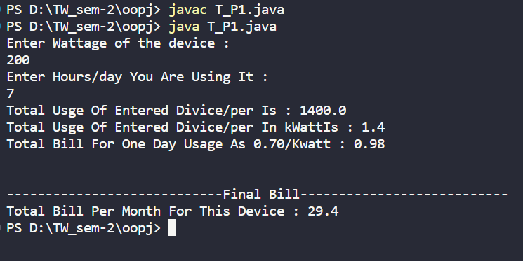

**Question – 2 : Write a java program using socket for client server communication.**

**Source Code :**

* **CLIENT :**

import java.net.*;

import java.io.*;

public class T_P2_CLIENT {

public static void main(String[] args) throws IOException {

try (Socket clientSocket = new Socket("localhost", 5000)) {

System.out.println("Connected to server");

try (BufferedReader in = new BufferedReader(new InputStreamReader(clientSocket.getInputStream()));

PrintWriter out = new PrintWriter(clientSocket.getOutputStream(), true);

BufferedReader stdIn = new BufferedReader(new InputStreamReader(System.in))) {

String userInput;

while ((userInput = stdIn.readLine()) != null) {

out.println(userInput);

System.out.println("Server response: " + in.readLine());

}

}

} catch (IOException e) {

System.err.println("Error in client: " + e.getMessage());

}

}

}

* **SERVER :**

import java.net.*;

import java.io.*;

public class T_P2_SERVER {

public static void main(String[] args) throws IOException {

try (ServerSocket serverSocket = new ServerSocket(5000)) {

System.out.println("Server started");

Socket clientSocket = serverSocket.accept();

System.out.println("Client connected");

try (BufferedReader in = new BufferedReader(new InputStreamReader(clientSocket.getInputStream()));

PrintWriter out = new PrintWriter(clientSocket.getOutputStream(), true)) {

String inputLine;

while ((inputLine = in.readLine()) != null) {

System.out.println("Received message: " + inputLine);

out.println("Received message: " + inputLine);

}

}

} catch (IOException e) {

System.err.println("Error in server: " + e.getMessage());

}

}

}

**Output :**

First of all run the SERVER code after that run the CLIENT code. Then write down Massage Client side ; the server will respond.

* 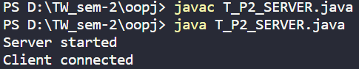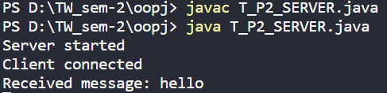**Server**

* 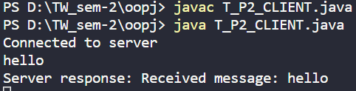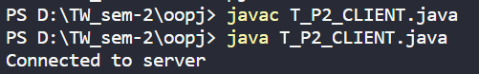**Client**